PRODUCT OVERVIEW

1. EQ switch button
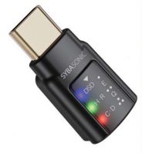

2. DSD/EQ1 indicator

3. Above 48KHz/EQ2 indicator

4. 48KHz and below/EQ3 indicator

1. EQ switch button: No EQ is set by default each time the power is turned on. Each time the button is pressed, it switches to the next EQ mode and the corresponding LED flashes. After 5 seconds, if there is no button operation, the LED stops flashing. The EQ cycle sequence is: No EQ -> Bass -> Treble -> Loudness -> No EQ......, long press for 1 second to turn off the EQ function, and when switching to no EQ mode, the three lights flash at the same time and then go out.
2. DSD/EQ1(Bass) indicator: It is always on when playing DSD music. If the button is pressed, this LED flashes if it is in EQ1 mode.
3. 48KHz and above/EQ2(Treble) indicator: It is always on when playing music above 48KHz. If the button is pressed, this LED flashes if it is in EQ2 mode.
4. 48KHz and below/EQ3(Loudness) indicator: It is always on when playing music below 48KHz. If the button is pressed, this LED flashes if it is in EQ3 mode.

